**Bootcamp FinTech – Tutoring**

**Mac OS**

May 20 session: Questions and items for review:

1. Git and GitHub
   * Overall review of Git, GitHub and the use of SSH key
   * Review how to submit first assignment via GitHub. Including to identify how to create a markdown file (.md)
   * Review if SSH Key has been set up correctly. When setting up in Terminal got this final message:
     + Terminal: *Hi javaranko! You’ve successfully authenticated, but GitHub does not provide shell access*.
     + This is what is showing in GitHub:
       - *JA FinTech*
       - *SHA256:wUHm5MTvImJN6QOG4TdLdu7Zkje5kEsmrlBuBp5gn68*
       - *Added on May 19, 2022*
       - *Never used — Read/write*
     + The instructions in bootcampspot shows:

*You should see an RSA fingerprint in your window. Enter “yes” only if it matches the one highlighted in the image below:*

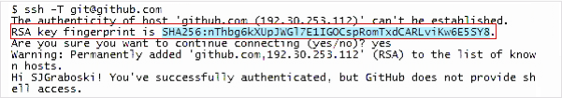

* Review how to complete the example provided in the video of the instructions for:
  + **How do I use Git and GitHub?**